ESPE 2024 – Group Registration Instructions

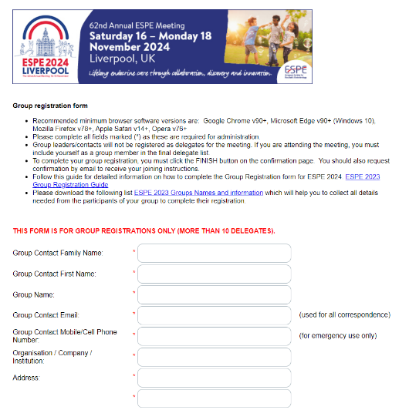
- Screen No 1 is to be completed by the group leader, please fill all the details as request on the below form. The group contact email will be used for all correspondence. Please click at the link ‘ESPE 2024 Group Names and Information to download the form. Once all details have been completed, please click ‘’next’’ to proceed to the next screen.

- Screen No 2. Section one of Screen 2 will provide you with information on registration fees. Please see below the Section 1. The registration fees will be available for you to select further along the registration process. This is covered later in the guide. Please read carefully the concession fee eligibility.

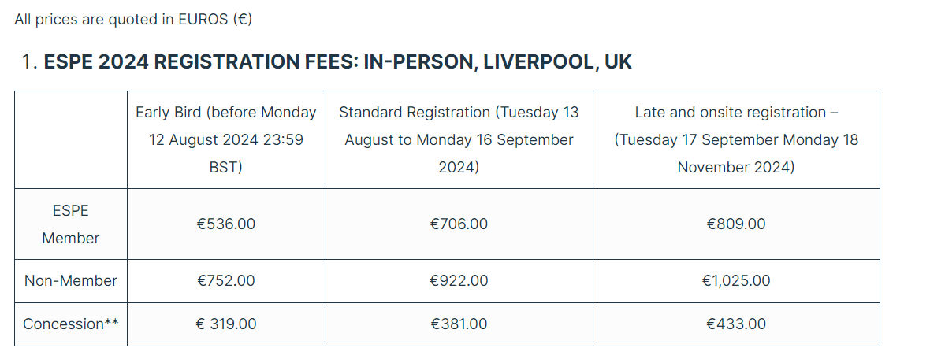

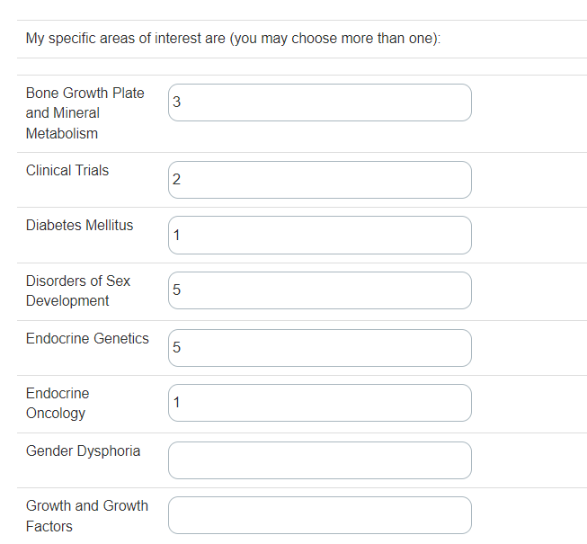
- The next section on Screen No 2 is the question ‘’my specific area of interest’’, regarding the interest that the group participants have. Should you, for example, have a group of 10 participants, please select the interest that are relevant to them, as in the picture below. You may choose more than one of each group participant as per their preference. Please use only numerical values.
- Section 3 of Screen No 2 is the section to select registration type. Please select the registration fees relevant to your group as in the below example.
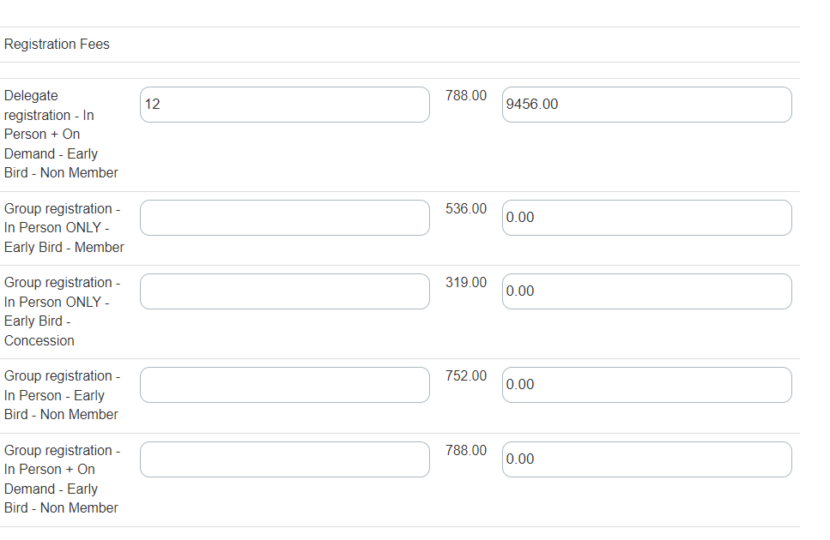

- Section 4, 5 and 6 and 7 of Screen 2 are the GDPR authorisation questions. Please complete them in accordance with the instructions you have received from the group participants. Please also confirm whether the delegate wishes to attend the ESPE social evening at an additional cost. Please use only numerical values.

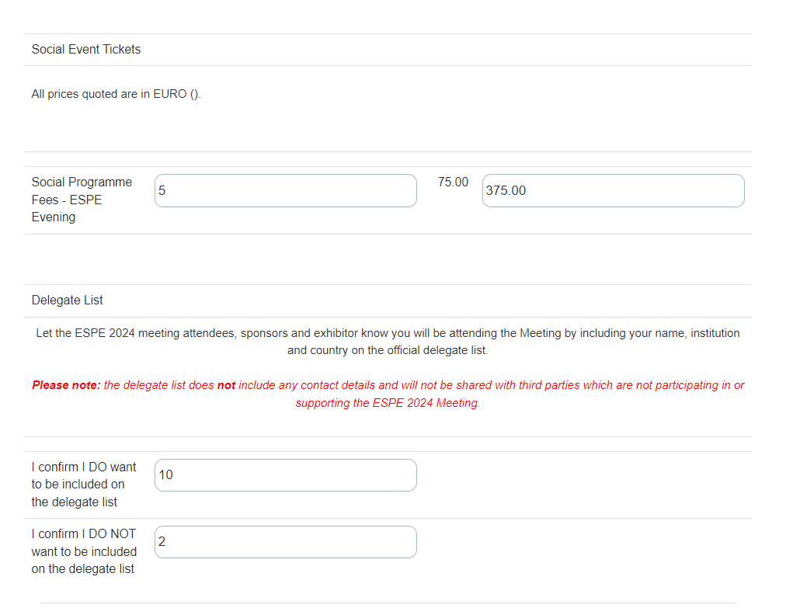

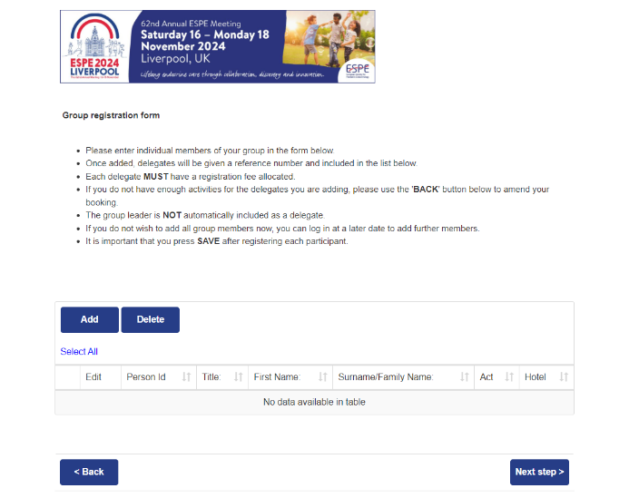
6.Once you have completed this page, please click on ‘’Next’’ to proceed to the next screen.

6. Screen No 3.

Adding participants to your group booking, please enter individual group members to your booking by clicking on ‘add’.

6.1 Once added, delegates will be given a reference number and included in the list below.

  - Each delegate MUST have a registration fee allocated. If you do not have enough activities for the delegates you are adding, please use the ‘Back’ button to amend your booking.

  - The Group Leader is NOT automatically included as a delegate

  - If you do not wish to add all group members now, you can log in at a later date to add further members. The same applies if you don’t have any names for your group, you can click ‘next’ and be directed to the payment screen to pay for your booking.

  - It is important that you press ‘’Save’’ after registering each participant.

6.6 By Clicking on ‘’Add’’ you will be directed to the following page, which is divided in 2 sections.

- Section 1 Group Participant, please complete all the relevant information about the participant you are registering. All the information that is required to complete the form in in the spreadsheet that you downloaded at the start of the group registration process. Do not forget to add a valid ESPE membership number when registering an ESPE member.
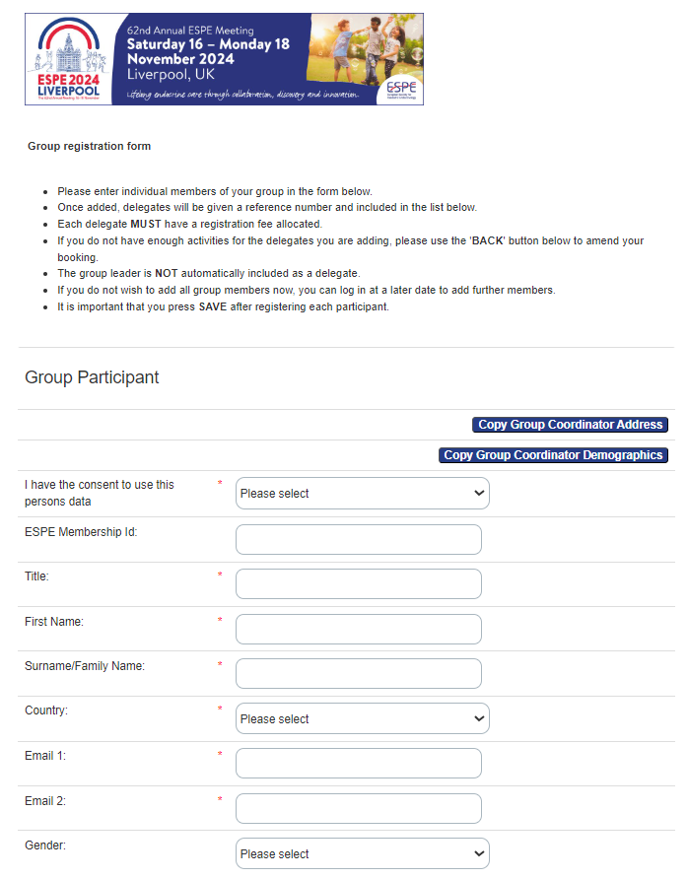

- Section 2 Participant Activities.

  - Select the relevant activities for the participant you are registering. For example, the below screen is detailing the activities available, if the delegate is interested in Adrenals, please fill the Adrenals box with number ‘’1’’ to represent the interest to the participant.

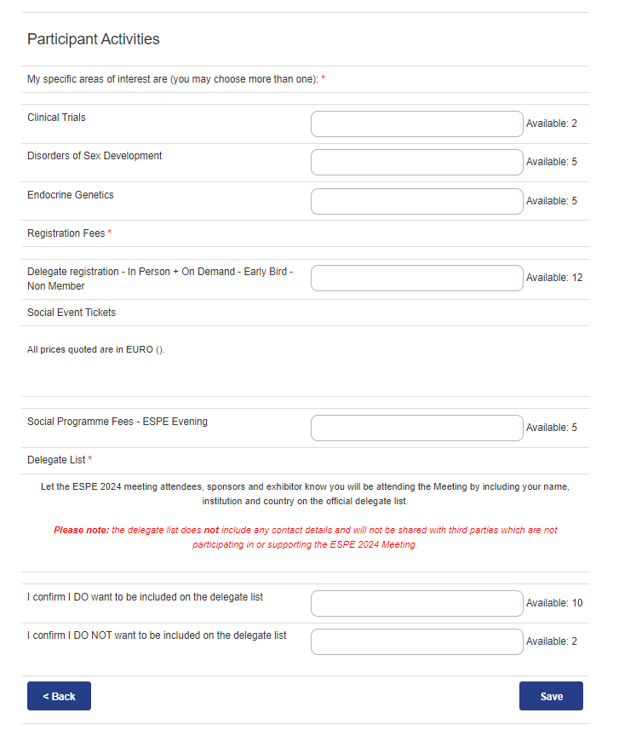
  - Please do the same for the mailing preferences, networking opportunities and delegate list. Please use only numerical values.

  - Please click on ‘Save’ to continue adding the participants to your list.
  - There are 2 options available after this to either add the participants one by one yourself, or include them all in the template you have downloaded at the start of group registration and email this form to us on espe2024@bioscientifica.com and we will add them on your behalf. Please note that we will email you to confirm once the process has finished so that you can check that all the details are correct.
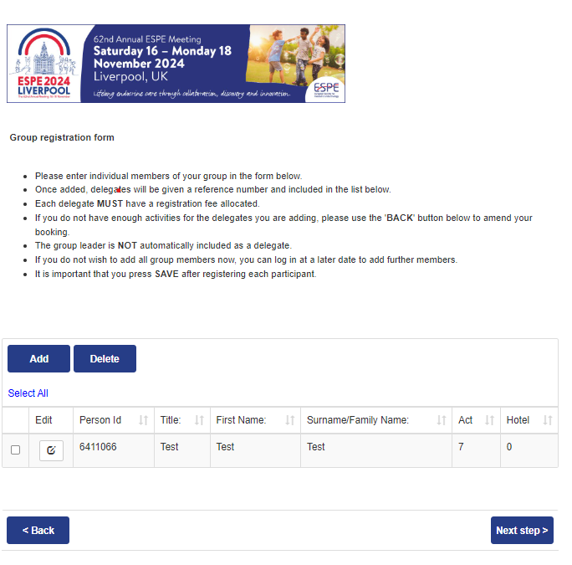
  - Once finished adding participants, click on ‘’Next’’ to be directed to the payment page.

- Final Section. Payment Page.
  - The payment options are either Worldpay, where you can pay on a credit / debit card, or bank transfer where the bank details are listed to make a wire transfer.
  - Please confirm the date of your payment and click on ‘’Pay’’ to complete your booking.

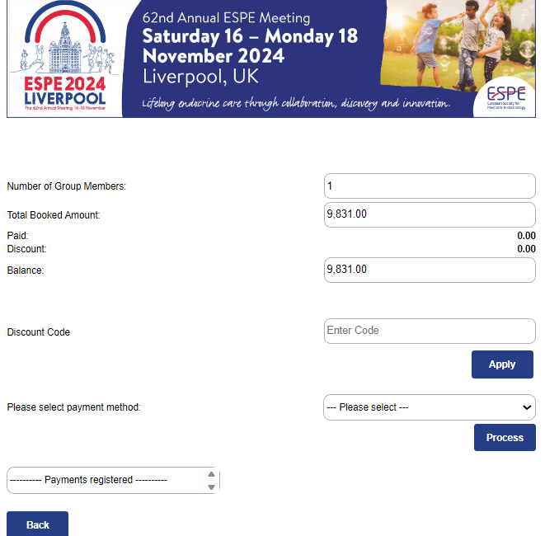

If you have any issues or questions please email espe2024@bioscientifica.com and we will be more than happy to assist you.

